**Personal Finance Tracker**

A Mini Project-102800401 report submitted

In partial fulfilment of the requirements for the Diploma of

Engineering/Technology

In

Information Technology

Semester – IV

By

**Janvi N Kalani (42302880501018)**

**Kavya B Patel (42302880501023)**

Faculty Guide

**Jay Pandya**

Lecturer

**Academic Year 2024-25 (Even)**

Department of Information Technology

G H Patel College of Engineering & Technology

Bakrol Road, Vallabh Vidyanagar

**CERTIFICATE**

This is to certify that the Mini Project work embodied in this report entitled “**Personal Finance Tracker Website**” was carried out by **Janvi N Kalani** **(42302880501018)** **& Kavya B Patel (42302880501023),** at G H Patel College of Engineering & Technology, for partial fulfilment of the Diploma in Engineering (IT) to be awarded by Charutar Vidya Mandal University (CVMU).

This Mini Project Report has been carried out under my supervision and is to the satisfaction of the department.

**Date:**

**Place:**

**Guide Head of Department**

Jay Pandya Dr. Nikhil Gondaliya

Lecturer Professor & Head

**Acknowledgement**

The completion of any Project work depends upon cooperation, co-ordination,

and combined efforts of several sources of knowledge. I would like to express

my deepest thanks to **Jay Pandya**, for his valuable inputs, guidance,

encouragement, wholehearted cooperation, and constructive criticism

throughout the duration of our project.

I hope that this Mini Project work report will provide all necessary

information required to readers to fulfil their aspiration. Man’s quest for

knowledge never ends. Theory and practices are essential and complimentary

to each other. I would like to express my sincere thanks to **Dr. Nikhil Gondaliya**

**(Head of Department)** for wholehearted support.

**Janvi N Kalani (42302880501018)**

**Kavya B Patel (42302880501023)**

**Abstract**

Managing personal finances effectively is crucial for financial stability and planning. The Personal Finance Tracker is a web-based application designed to help users track their income, expenses, and savings in an organized manner. This system provides users with an intuitive interface to monitor their financial activities, set budgets, and analyze spending patterns through visual reports.

The platform includes features such as secure user authentication, transaction management, budget planning, savings tracking, and data visualization using Chart.js. Users can log their financial transactions, categorize expenses, and generate insightful reports. The system ensures secure data management through password encryption, session-based authentication, and SQL-injection protection.

Developed using HTML, CSS, JavaScript for the frontend, PHP for the backend, and MySQL for database storage, the Personal Finance Tracker is designed to provide a seamless and structured financial management experience. This report explores the system’s architecture, workflow, implementation details, and potential future enhancements to improve usability and functionality. By offering a centralized platform for financial tracking, the system aims to help users gain better control over their personal finances and make informed financial decisions.

**TABLE OF CONTENTS**

**Chapter 1: Introduction**

1.1 Overview of the Project …………………………………………………………………….4  
1.2 Features of the Website …………………………………………………………………….5  
1.3 Technologies Used …………………………………………………..………………………..6

**Chapter 2: User Management**

2.1 User Registration & Login ………………………………………………………………… 8  
2.2 Contact & Support ……………………………………………………………………………10

**Chapter 3: Dashboard & Core Features**

3.1 Home Page Overview ………………………………………………………………………. 12  
3.2 Transactions ………………………………..…………………………………………………….14  
3.3 Budget & Savings Management …………………………………………………………15  
3.4 Summary & Reports ………………………………………………………………………….16

**Chapter 4: Data Visualization**

4.1 Using Chart.js for Insights ………………………………………………………………….18  
4.2 Graphical Analysis of Financial Data ………………………………………………….20

**Chapter 5: Security & Database Management**

5.1 User Data & Security ………………………………………………………………………….22

**Chapter 6: Conclusion & Future Scope**

6.1 Summary of the Project …………………………………………………………………….23  
6.2 Future Enhancements ……………………………………………………………………….23

**Table of Figures**

Figure 1.1: Overview of Website……………………………………………………………4

Figure 1.2: Features of Website…………………………………………………………….5

Figure 2.1: User Registration…………………………………………………………………8

Figure 2.2: Login Page UI ………………………………………………………………………9

Figure 2.3: Contact & Support……………………………………………………………...10

Figure 3.1: Dashboard of website …………………………………………………………12

Figure 3.2: Dashboard ………………………….………………………………………………13

Figure 3.3: Transactions………………………………………………………………………. 17

Figure 3.4: Budget & Savings Management ……………………………………………18

Figure 3.5: Summary & Reports ……….…………………………………………………… 19

**CHAPTER 1**

**INTRODUCTION**

**1.1 Overview of Personal Finance Management**

Managing personal finances is key to financial stability. A **Finance Tracker** helps individuals track income, expenses, and savings in an organized way. It enables better budgeting, prevents overspending, and supports financial planning. By using a Finance Tracker, users can make informed decisions, improve financial habits, and work towards financial security.

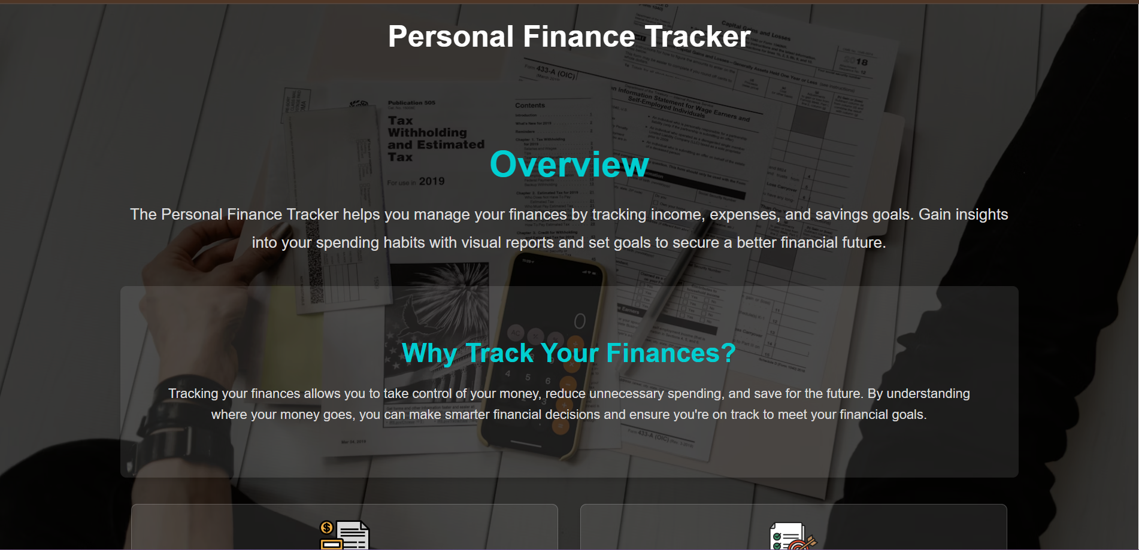

**Figure 1.1**

**1.2 Features of the Website**

* User-friendly interface
* Secure user authentication
* Real-time transaction tracking
* Budget and savings management
* Graphical data representation using Chart.js
* Data backup and security measures

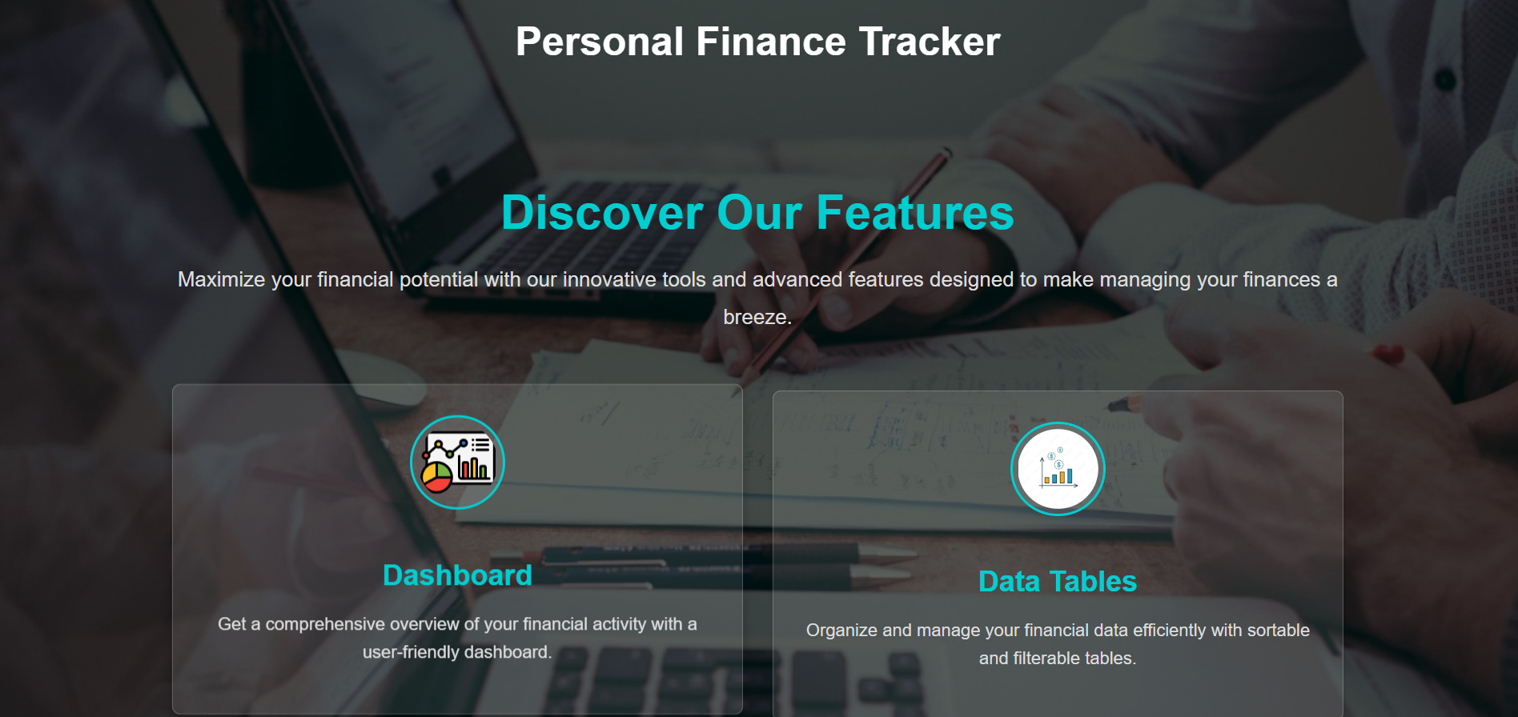

**Figure 1.2**

**1.3 Technologies Used**

**The Finance Tracker website is built using the following technologies:**

* **Frontend: HTML, CSS, JavaScript**
* **Backend: PHP**
* **Database: MySQL**
* **Visualization: Chart.js**
* **Security: Password encryption, session management**

**CHAPTER 2**

**User Management**

**2.1 User Registration**

* Users can create an account using their email and password.
* Registration includes basic details and validation.
* Email verification for added security.

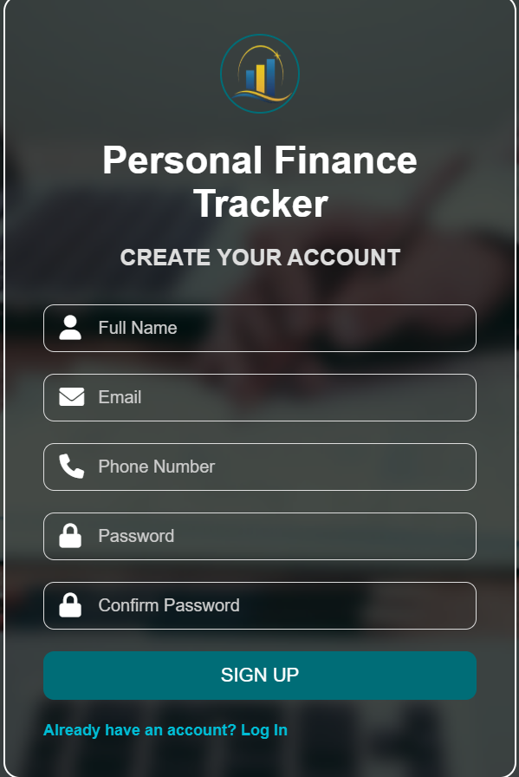

**Figure 2.1**

**2.2 User Login & Authentication**

* Secure login system with encrypted passwords.
* Session-based authentication for security.
* Forgot password feature for account recovery.

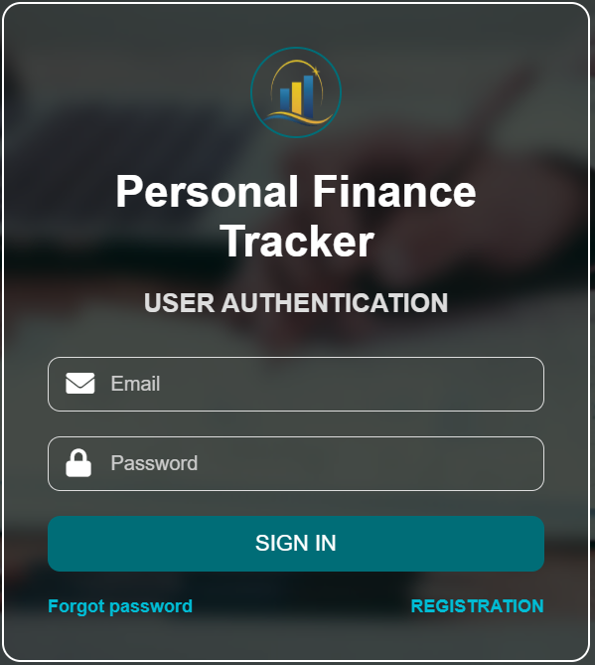

**Figure 2.2**

**2.3 Contact & Support**

* A contact form allows users to reach out for support.
* Email-based queries and a chatbot for instant responses.

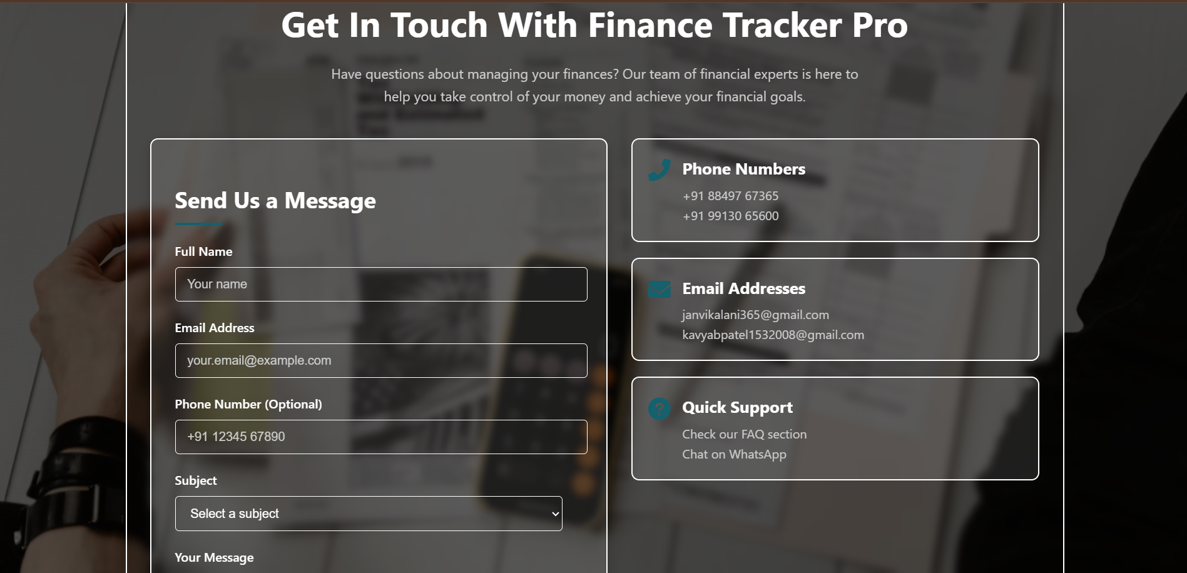

**Figure 2.3**

**CHAPTER 3**

**Dashboard & Core Features**

**3.1 Website Home Page Overview**

* The homepage provides an introduction to the platform and its purpose.
* Sections include an overview, features, 'Why Choose Us?', and contact details.
* Navigation links direct users to essential sections such as login, signup, and support.

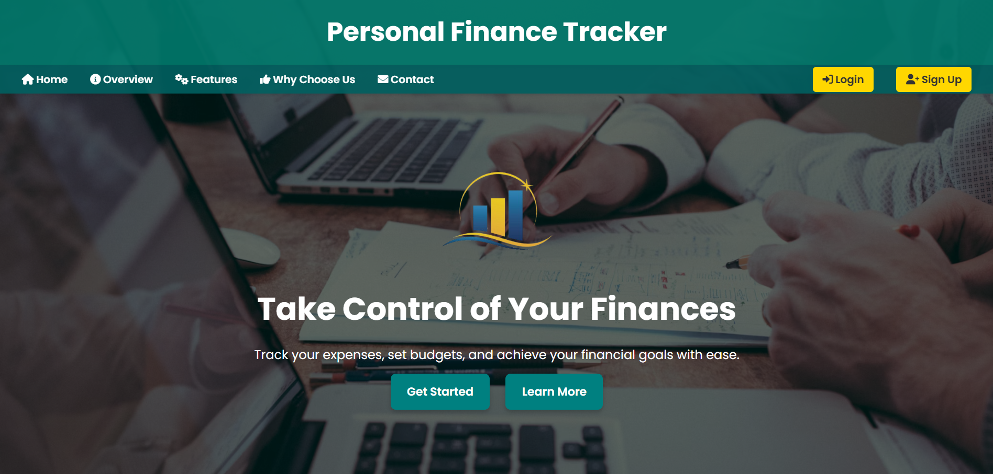

**Figure 3.1**

**3.2 Dashboard Home Overview**

* The dashboard home provides users with an overview of their financial status.
* Displays a summary of recent transactions, budget status, and savings progress.
* Quick access to transaction management, reports, and settings.

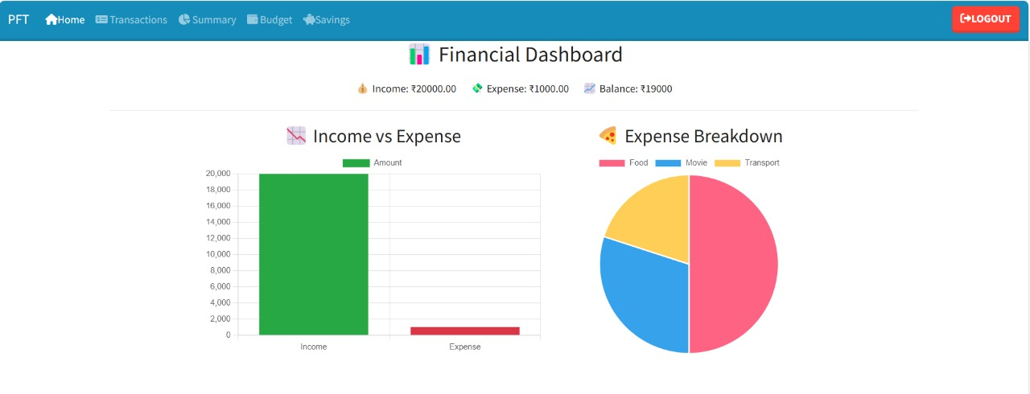

**Figure 3.2**

**3.3 Transactions (Income & Expenses)**

* Users can log their income and expenses.
* Categories such as food, Salary, Movie, Shopping, Transport and Other help track spending.
* Transaction history is available for easy review.

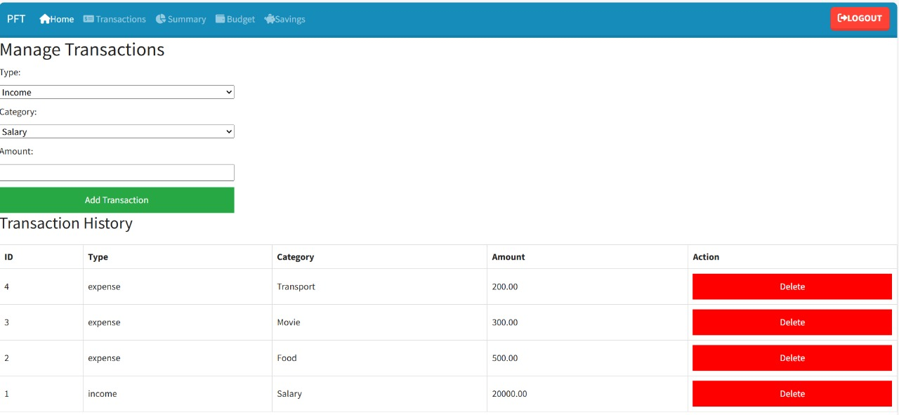

**Figure 3.3**

**3.4 Budget & Savings Management**

* Users can set monthly budgets for different categories.
* Savings goals can be defined and tracked in real time.

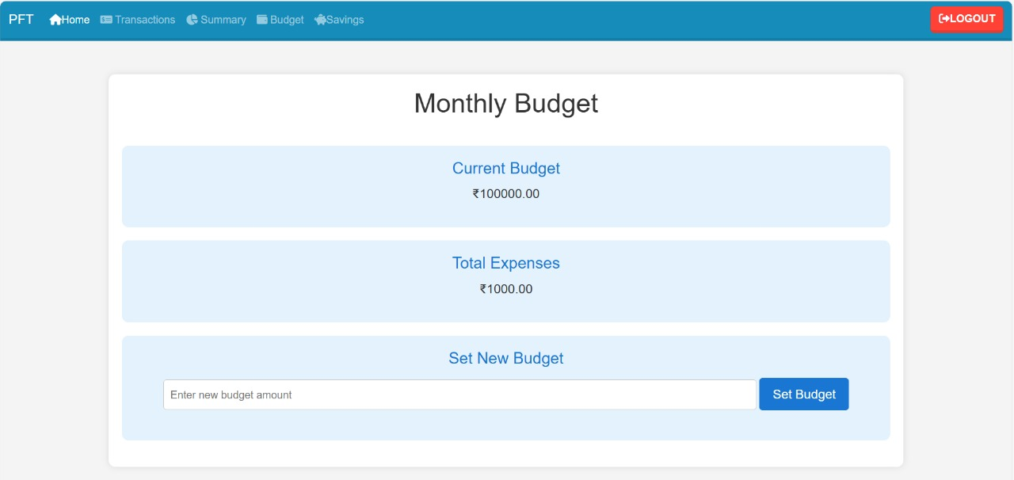

**Figure 3.4**

**3.5 Summary & Reports**

* Displays overall financial performance.
* Highlights spending patterns and savings progress.

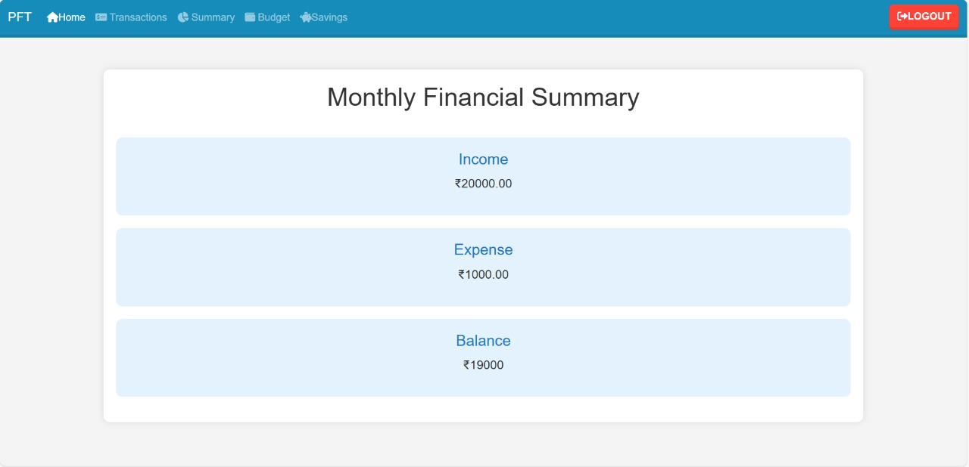

**Figure 3.5**

**Chapter 4**

**Data Visualization**

**4.1 Using Chart.js for Insights**

* Implements Chart.js for dynamic financial charts.
* Pie charts for expense distribution.
* Line charts for income vs. expenses over time.

**4.2 Graphical Analysis of Financial Data**

* Visual representation of spending habits.
* Helps users understand their financial trends at a glance.

**Chapter 5**

**Security & Database Management**

**5.1 User Data & Security**

* Secure authentication with password hashing.
* Session management for user safety.
* SQL injection protection and secure API calls.

**Chapter 6**

**Conclusion & Future Scope**

**6.1 Summary of the Project**

The Finance Tracker website successfully provides users with an intuitive platform to manage their finances. With secure login, budgeting tools, and visual reports, users can take full control of their financial health.

**6.2 Future Enhancements**

* **Mobile App Development**: Extending functionality to mobile devices.
* **AI-Powered Financial Insights**: Smart spending recommendations.
* **Multi-Currency Support**: Enabling global financial tracking.

**References:**

1. HTML, CSS, and JavaScript Documentation
2. PHP and MySQL Official Documentation
3. Chart.js API Reference
4. Security Best Practices in Web Development